Chapter 9 Part 2 – Demo Requirements
Oct 17, 2026 · @Jim Kaufmann

Overview
Three in-class demos that use the same Chapter 9 skills as Labs 1–3, built on different, smaller problems so the lab code is not given away.
- Language / project type: C# Windows Forms App
- Project names: Demo1, Demo2, Demo3
- Rule (same as the labs): each demo must use classes and objects exactly as shown in its UML diagram.
- UML key: - private, + public, { get } read-only property, { get, set } auto-implemented property, «const» constant. A filled diamond means composition (the whole creates and owns its part); a hollow diamond means aggregation (the part is created elsewhere and handed in).

Demo 1 – Coffee Order (enums + composition)
A coffee shop form where the user enters a name, picks a coffee size, and adds the order to a list that keeps a running total. Mirrors Lab 1 (FoodOrder) with one menu item and no toppings.

UML
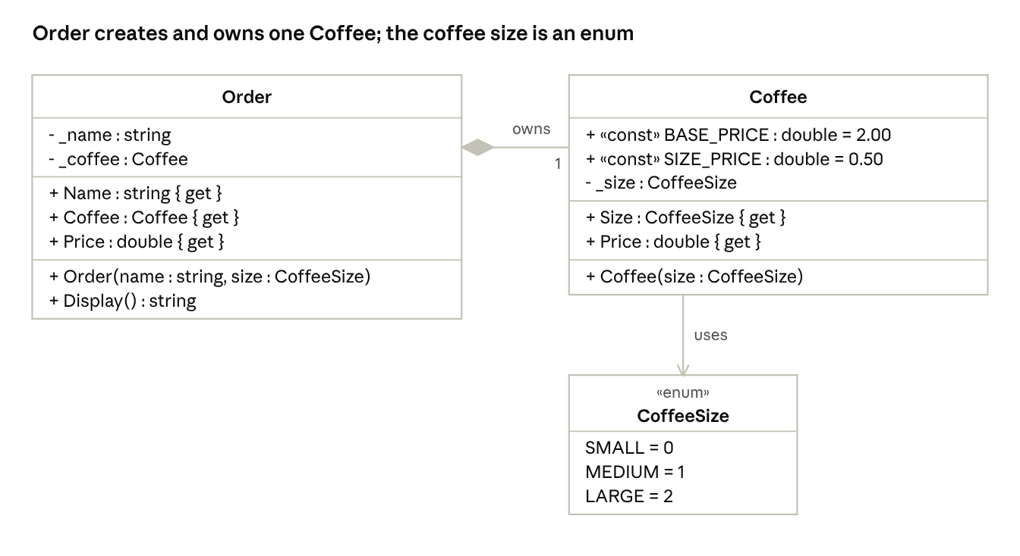
Demo 1 UML · Order, Coffee, CoffeeSize
- CoffeeSize values: SMALL = 0, MEDIUM = 1, LARGE = 2.
- Coffee.Price = BASE_PRICE + (int)Size × SIZE_PRICE, so Small $2.00, Medium $2.50, Large $3.00.
- Order(name, size) creates its own new Coffee(size) inside the constructor. That is the composition: the Order owns the Coffee.
- Order.Price returns the Coffee's price.
- Order.Display() returns "{Name} - {SIZE} coffee - {Price:C}", for example Fred - LARGE coffee - $3.00.

Form controls
Control | Name | Notes
TextBox | txtName | Name on the order
RadioButton (x3) | radSmall, radMedium, radLarge | Small checked by default
Button | btnAdd | "Add to Order"
ListBox | lstOrders | One line per order
Label | lblTotal | "Total: $0.00"
Label | lblError | Red text, blank until an error

Behavior
- If the name is blank, show "Name required" in lblError and stop.
- Convert the checked radio button to a CoffeeSize value.
- Create a new Order object with the name and size.
- Add order.Display() to lstOrders.
- Add order.Price to a running total and update lblTotal.
- Clear the name, clear lblError, and set focus back to txtName.

Sample output
Fred - LARGE coffee - $3.00
Wilma - SMALL coffee - $2.00
Total: $5.00

Demo 2 – Assignment Tracker (auto-properties + array of objects)
A form where a student enters up to 10 assignments, then lists every assignment due on or before a chosen date. Mirrors Lab 2 (Conferences) but searches by a single "due by" date instead of a date range.

UML
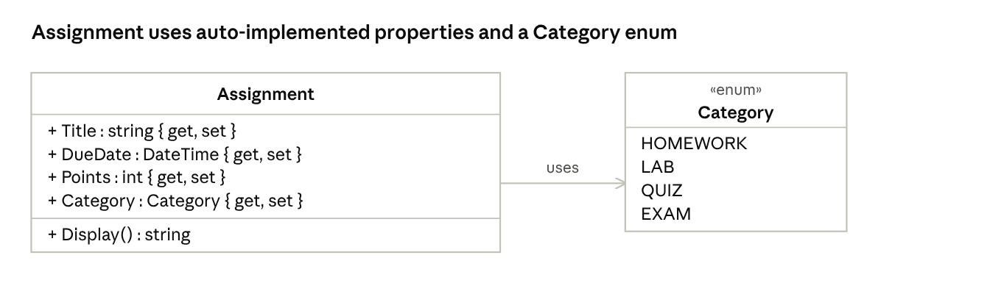
Demo 2 UML · Assignment, Category
- All four properties are auto-implemented: public string Title { get; set; }.
- Display() returns "{Title} ({CATEGORY}) - {Points} pts - due {DueDate:d}", for example Lab 1 (LAB) - 20 pts - due 10/20/2026.
- The form stores the objects in Assignment[] assignments = new Assignment[10] plus an int count.

Form controls
Control | Name | Notes
TextBox | txtTitle | Assignment title
DateTimePicker | dtpDueDate | Due date
TextBox | txtPoints | Whole number greater than 0
ComboBox | cboCategory | DropDownList style, filled from the Category enum
Button | btnAdd | "Add"
Label | lblCount | "Assignments: 0/10"
Label | lblTotalPoints | "Total Points: 0"
DateTimePicker | dtpDueBy | Search date
Button | btnSearch | "Show Due By"
ListBox | lstOutput | Added items and search results

Behavior
When Add is clicked:
- If the title is blank or points is not a whole number above 0, show a message and stop.
- If 10 assignments are already stored, show "List is full" and stop.
- Create a new Assignment object using object initializer syntax and store it at assignments[count], then add 1 to count.
- Add Display() to lstOutput and update lblCount and lblTotalPoints.
- Clear the text fields and set focus to txtTitle.
When Show Due By is clicked:
- Clear lstOutput.
- Loop through the first count items and show each one whose DueDate.Date <= dtpDueBy.Value.Date.
- If nothing matched, show "No assignments found".
Set the tab order so Tab moves Title → Due Date → Points → Category → Add.

Sample output
Assignments: 3/10 Total Points: 120
Show Due By 10/25/2026:
Lab 1 (LAB) - 20 pts - due 10/20/2026
Quiz 3 (QUIZ) - 50 pts - due 10/24/2026

Demo 3 – Pet Lookup (search an array of objects that hold objects)
A vet clinic form where the user types a pet's name and sees the pet's species and its owner's contact info. Mirrors Lab 3 (Paladins) with one contained object (Owner) instead of five Abilities.

UML
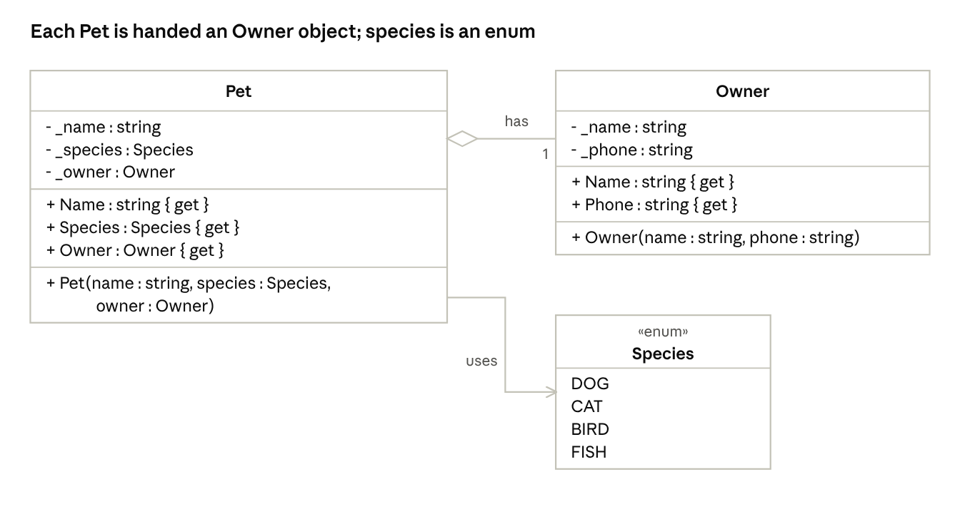
Demo 3 UML · Pet, Owner, Species
- All fields are private and set only through the constructor; properties are read-only.
- Each Owner is created first and then passed into the Pet constructor (aggregation).
- The form holds a Pet[] array filled with the data below when the form is created.

Data
Pet | Species | Owner | Phone
Biscuit | DOG | Maria Lopez | 314-555-0142
Pickles | CAT | Dev Patel | 314-555-0177
Kiwi | BIRD | Sam Carter | 636-555-0119
Bubbles | FISH | Ana Ruiz | 314-555-0163

Form controls
Control | Name | Notes
TextBox | txtSearch | Pet name to find
Button | btnSearch | "Search" (set as the form's AcceptButton)
TextBox | txtResult | Multiline, read-only

Behavior
- Loop through the Pet array.
- Match names without regard to case or extra spaces ("kiwi", " KIWI " both match).
- On a match, show the pet and owner using the object's properties, such as pet.Owner.Name.
- If no pet matches, show "Pet not found".

Sample output
Search: kiwi
Kiwi
BIRD
Owner: Sam Carter
Phone: 636-555-0119
Search: rex
Pet not found

Demo-to-lab map
Each demo shows the pattern; the matching lab adds the parts students still have to work out.
Demo | Lab | Concepts shown | Left for the lab
1 Coffee Order | Lab 1 FoodOrder | Enum, constants, composition, read-only properties, running total | Two optional items, topping/flavor arrays, limits on selections
2 Assignment Tracker | Lab 2 Conferences | Auto-properties, enum in a ComboBox, array of objects with a count, DateTime compare | Enum with set values, typed date parsing, begin/end range search
3 Pet Lookup | Lab 3 Paladins | Constructor-only fields, object inside an object, case-insensitive search of an array | Five contained Ability objects, champion data entry, formatted output

